Supplementary information

**Molecular diversity informed modeling of litter decomposition**

Arjun Chakrawal1, Luciana Chavez Rodrigez2, Stefano Manzoni3, Satish Karra1, Odeta Qafoku1, and Emily Graham1

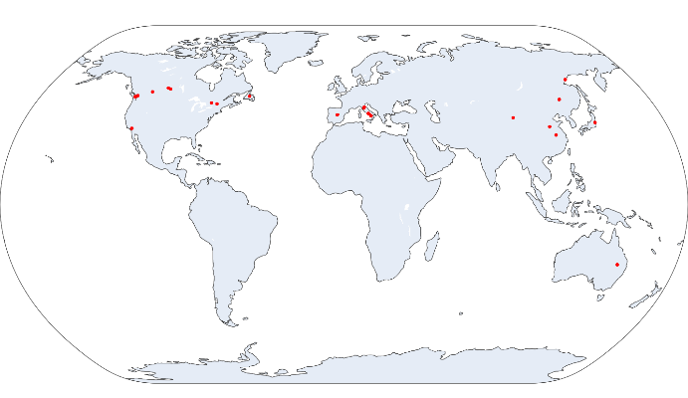

Figure S1: Geographic locations of litter sampling sites collated from literature for this study.

Figure S2: (A) The range of variation of the fraction of organic compounds in litter estimated using molecular mixing model and 13C NMR data. (B) Nash–Sutcliffe modeling efficiency coefficient (NSE) and (C) root mean square error (RMSE in gC/gC litter) from the predicted NMR chemical shift using molecular mixing model and observed NMR chemical shift for the litter samples. The horizontal lines in the violin plots indicate quartiles: the median (middle line), upper quartile (Q3) and lower quartile (Q1). The box in boxplot shows the interquartile range (IQR), with the median marked by a horizontal line. Whiskers extend to values within 1.5 times the IQR from the quartiles and outliers beyond the whiskers are indicated by individual markers.

Figure S3 Relationship between the fraction of lignin carbon estimated from the molecular mixing model and the proportion of aromatic carbon, defined as the sum of signal intensities in the aromatic (110–145 ppm) and phenolic (145–165 ppm) regions of the ¹³C NMR spectrum, across all litter samples. This linear relationship was used to convert the scaling factor *a* in the lignin decay modifier employed by Chakrawal et al. (2024) rom aromatic C to lignin C. Specifically, the value *a* = 0.15 used for aromatic C corresponds to approximately *a* = 0.28 when expressed in terms of lignin C.

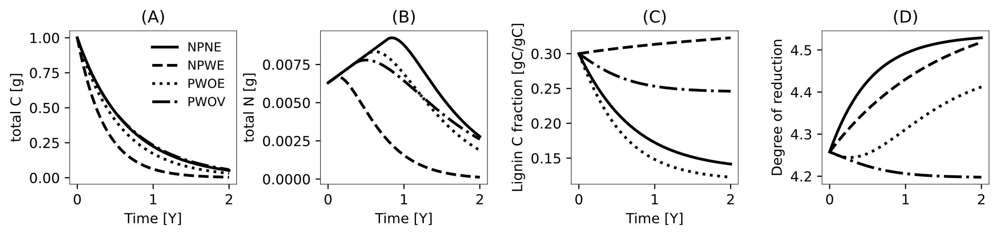

Figure S4 Temporal dynamics of total C, total N, lignin fraction, and degree of reduction during litter decomposition across model scenarios. Model simulation initial conditions and parameter values are the same as Figure 3 from main text.

Figure S5 Scatter plot of modeled and observed mass remaining of carbohydrate, protein, lignin, lipid and carbonyl among four model scenarios illustrate using different colors for N retention strategy. The grey line represents 1:1 line.

Figure S6 (A) Scatter plot of modeled and observed mass remaining of carbohydrate, protein, lignin, lipid and carbonyl among four model scenarios illustrate using different colors for flexible CUE strategy. The grey line represents 1:1 line.

Table S1 Chemical shift regions and their representative classes of organic compounds for five classes of organic compounds, and their elemental composition and nominal oxidation state of carbon (NOSC) (Nelson & Baldock, 2005), with representative classes of compounds (Knicker & Lüdemann, 1995).

|  |  |  |  |  |  |  |
| --- | --- | --- | --- | --- | --- | --- |
| Chemical shift region | Representative classes of compounds included | Carbohydrates | Proteins | Lignins | Lipids | Carbonyls |
| Alkyl C (0–45 ppm) | aliphatic compounds, lipids, waxes | 0 | 39.6 | 10.5 | 75.6 | 0 |
| Methoxy (45–60 ppm) | lignins substituents, amino acids, amino sugars | 4.3 | 21.9 | 13.8 | 4.5 | 0 |
| O-alkyl (60-95 ppm) | carbohydrates, lignins propyl side chains | 79 | 2.1 | 12.5 | 9 | 0 |
| Di-O-alkyl (95-110 ppm) | carbohydrates | 15.7 | 0 | 8.6 | 0 | 0 |
| Aromatic (110-145 ppm) | Aromatic hydrocarbon | 1 | 7.5 | 30.6 | 3.6 | 0 |
| Phenolic (145-165 ppm) | phenyl-propylene subunits of lignins | 0 | 2.5 | 19.5 | 0.7 | 0 |
| Carbonyl (165-210 ppm) | organic acids and peptides | 0 | 26.4 | 4.6 | 6.6 | 100 |
| Elemental formula |  |  |  |  |  |  |
| NOSC |  | 0 | 0.034 | -0.38 | -1.47 | 3 |

Table S2 Description of symbols used in the litter decomposition model, including parameter names, units, and value source.

|  |  |  |  |  |
| --- | --- | --- | --- | --- |
| **Symbol** | **Description** | **Value** | **Unit** | **Source** |
|  | integrated values of chemical shift regions of organic compounds |  | ppm |  |
|  | integrated values of chemical shift regions of litter sample |  | ppm |  |
|  | Carbon-to-Nitrogen ratio of proteins | 3.2 | gCgN-1 |  |
|  | Carbon-to-Nitrogen ratio of litter | Observed | gCgN-1 |  |
|  | Carbon-to-Nitrogen ratio of microorganism | 16 | gCgN-1 | (Zhang & Elser, 2017) |
|  | vector containing fraction of five organic compounds |  | gCgC-1 | calculated |
|  | is the mass of C in each pool, = or |  | gC | calculated |
|  | uptake rate of pool |  | gC d-1 |  |
|  | Maximum C use efficiency |  | - | calculated |
|  | C use efficiency |  | - | calculated |
|  | fraction of microbial mortality transferred to pool | , = 0.32, ,, and | - | Beidler et al. (2020) |
|  | Lignin modifier for pool |  | - | calculated |
|  | rate constant of pool |  | d-1 | fitted |
|  | mass of N in protein pool | Observed | gN |  |
|  | microbial growth rate |  | gC d-1 | calculated |
|  | microbial mortality rate |  | gC d-1 | calculated |
|  | net N exchange rate from inorganic pool |  | gN d-1 | calculated |
|  | N retention factor |  | - | calculated |
|  | supply rate of inorganic N |  | gN d-1 | calculated |
|  | scaling coefficient | 0.28 | gC gC-1 | (Chakrawal et al., 2024) |

Table S3 Initial fraction of carbon in five fractions for six litter types in Figure 2.

|  |  |  |  |  |  |  |  |  |
| --- | --- | --- | --- | --- | --- | --- | --- | --- |
| **Study** | **Litter type** | **Species** | **C:N** | **Carbohydrate [gC/gC]** | **Protein [gC/gC]** | **Lignin [gC/gC]** | **Lipid [gC/gC]** | **Carbonyl [gC/gC]** |
| Li et al 2020 | Crop residue | Wheat | 53.5 | 0.747 | 0.059 | 0.119 | 0.057 | 0.017 |
| Bonanomi et al 2013 | Grass | A. mauritanicus | 40.1 | 0.600 | 0.079 | 0.238 | 0.059 | 0.024 |
| Bonanomi et al 2013 | Leaf | A. unedo | 25.2 | 0.359 | 0.126 | 0.296 | 0.197 | 0.022 |
| Almendros et al 2000 | Needle | Pinus radiata | 37.3 | 0.376 | 0.085 | 0.205 | 0.277 | 0.056 |
| Wang et al 2013 | Root | M. macclurei | 38.5 | 0.380 | 0.082 | 0.271 | 0.213 | 0.054 |
| Mathers et al 2007 | Wood | Mulga twigs | 32.6 | 0.621 | 0.097 | 0.103 | 0.152 | 0.028 |

Beidler, K. V., Phillips, R. P., Andrews, E., Maillard, F., Mushinski, R. M., & Kennedy, P. G. (2020). Substrate quality drives fungal necromass decay and decomposer community structure under contrasting vegetation types. *Journal of Ecology*, *108*(5), 1845–1859. https://doi.org/10.1111/1365-2745.13385

Chakrawal, A., Lindahl, B. D., & Manzoni, S. (2024). Modelling optimal ligninolytic activity during plant litter decomposition. *New Phytologist*, *n/a*(n/a). https://doi.org/10.1111/nph.19572

Knicker, H., & Lüdemann, H.-D. (1995). N-15 and C-13 CPMAS and solution NMR studies of N-15 enriched plant material during 600 days of microbial degradation. *Organic Geochemistry*, *23*(4), 329–341. https://doi.org/10.1016/0146-6380(95)00007-2

Nelson, P. N., & Baldock, J. A. (2005). Estimating the molecular composition of a diverse range of natural organic materials from solid-state 13C NMR and elemental analyses. *Biogeochemistry*, *72*(1), 1–34. https://doi.org/10.1007/s10533-004-0076-3

Zhang, J., & Elser, J. J. (2017). Carbon:Nitrogen:Phosphorus Stoichiometry in Fungi: A Meta-Analysis. *Frontiers in Microbiology*, *8*. https://doi.org/10.3389/fmicb.2017.01281